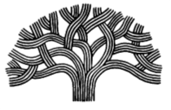

CITY OF OAKLAND

Youth Advisory Commission General Meeting Minutes

Meeting Date: October 10, 2019
Meeting Time: 5:00 pm-7:00 pm
Meeting Location: 150 Frank Ogawa Plaza, 4th Floor, Conference Room 1

Minutes completed by Falilah Bilal

There were 14 Commissioners present at this meeting. Please see sign in sheet for detailed names.

The Commissioners enjoyed the provided food and had friendly conversation.

The meeting started with a team building activity.

Youth Leadership Institute provided a training on Theories of Youth Development and How to Assess Your Leadership Style.

The Commissioners actively participated in the training and expressed learning more about themselves and their approach to leadership.

Meeting adjourned at 7:00 pm.

